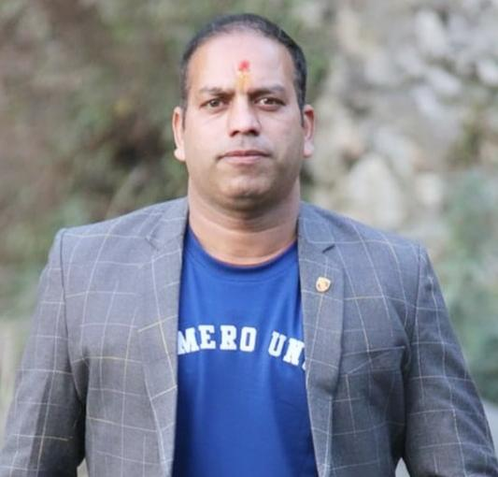

MR. SANJAY KUMAR GAIROLA

FACULTY OF MANAGEMENT

NIMBUS ACADEMY OF MANAGEMENT

Area

Marketing And Human resource management

Contact

Email: [sanjaygairola999@gmail.com](mailto:sanjaygairola999@gmail.com)

Phone: 7088019933

Education

Pursuing Ph.D. from Monad University, Hapur (UP)

M.B.A From U.T.U in 2013

M.A. Sociology in 2018

Teaching

Marketing Management, Consumer Behavior, Rural Marketing

Academic Experience

10 Years of teaching excellence

Academic Conferences and FDPs

1. Participated in AICTE online FDP on **“Design Thinking”** at **Graduate School of Management Studies, GTU.**
2. Attended state level workshop on **VIRTUAL LABS, IIT DELHI** at **ICFAI University, Dehradun.**
3. Attended **EXAMINATION REFORMS WORKSHOP** organized by **AICTE** at **Tula’s Institute, Dehradun.**
4. Attended International webinar **“LEAN SUPPLY CHAIN MANAGEMENT”** at **SNS College of Technology, Coimbatore.**